**GOVERNMENT ARTS AND SCIENCE COLLEGE VANUR.**

**BUILD AN EVENT MANAGEMENT SYSTEM USING SALESFORCE**

PROJECT BASED EXPERIMENTAL LEARNING PROGRAM

SALESFORCE

2023

**By**

**M.Dinesh**

**III B.Sc.Mathematics**

# INTRODUCTION

## 1.1 Overview

Eventmanagement is the process of creating and maintaining an event. This process spans from the very beginning of planning all the way to post-event strategizing.

At the start, an event manager makes planning decisions, such as the time, location, and theme of their event. During an event, event managers oversee the event live and make sure things run smoothly. After an event, event managers are tasked with reviewing event data, submitting KPI and ROI findings, and staying on the ball for any post-event offerings.

All different branches of planning go into event management, including various types of sourcing, designing, regulation checks, and on-site management. In event management, you could be in the process of creating a conference, a product launch, an internal sales kick-off, or even a wedding. Really, any event that requires considerable planning and execution is event management.

.

## 2. problem Deffinition & Design Thinking

### 2.1 Empathy Map

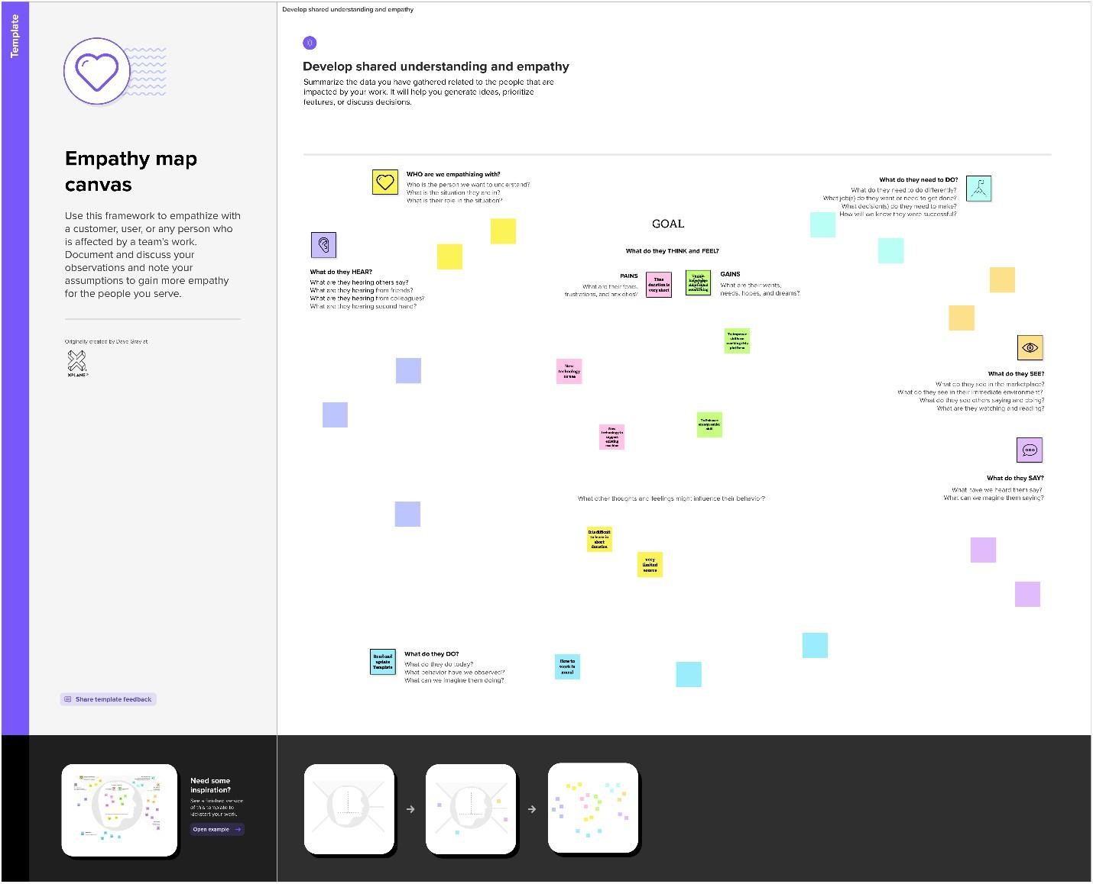

### 2.2 Ideation & Brainstorming map Screenshot

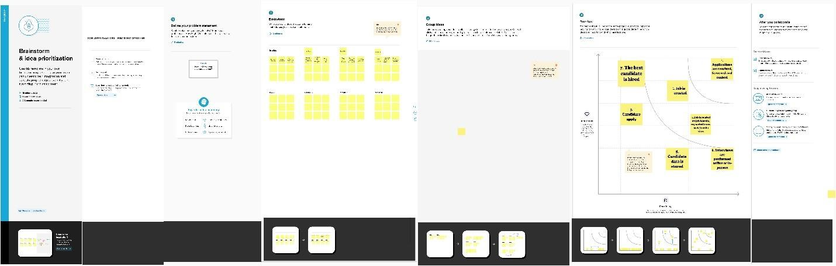

## 3. RESULT

**3.1 Data Model:**

|  |  |  |
| --- | --- | --- |
| Object Name | Fields in the Object | |
| Field label | Data type |
| Object 1 | Events | Auto Number |
| Object 2 | Attendees | Auto Number |
| Object 3 | Speakers | Auto Number |
| Object 4 | Vendor | Auto Number |

### 3.2 Activity & Screenshort

**Create an Event**

**Activity 1**

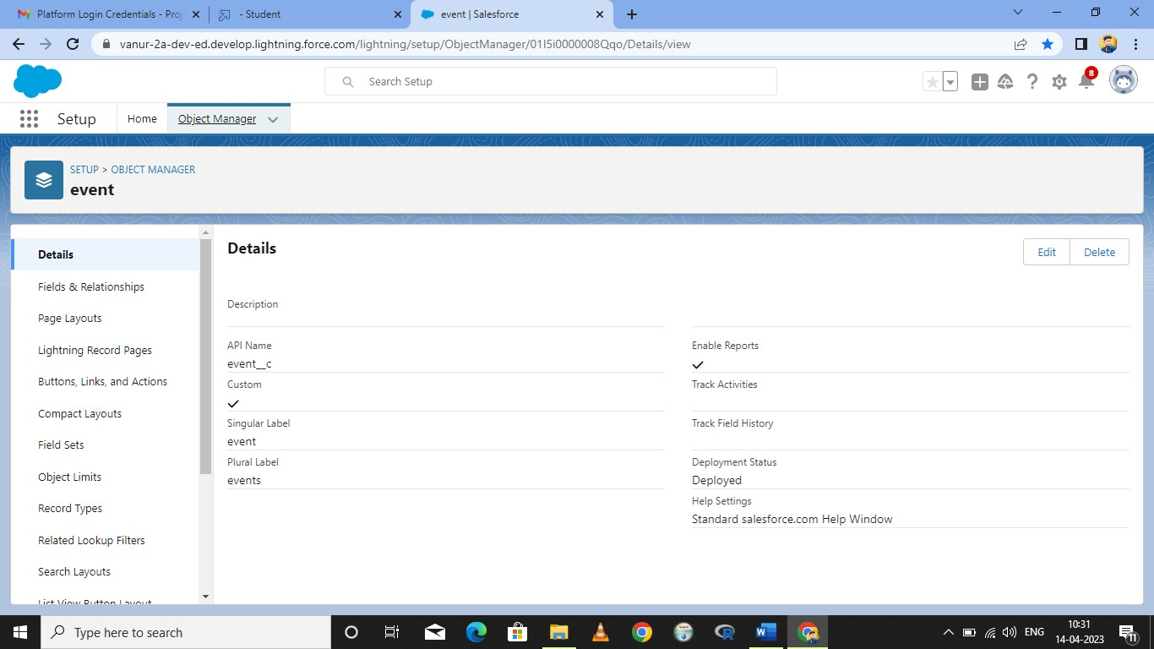

**Activity 2:**

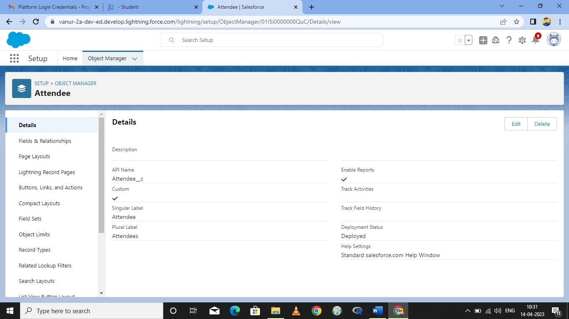

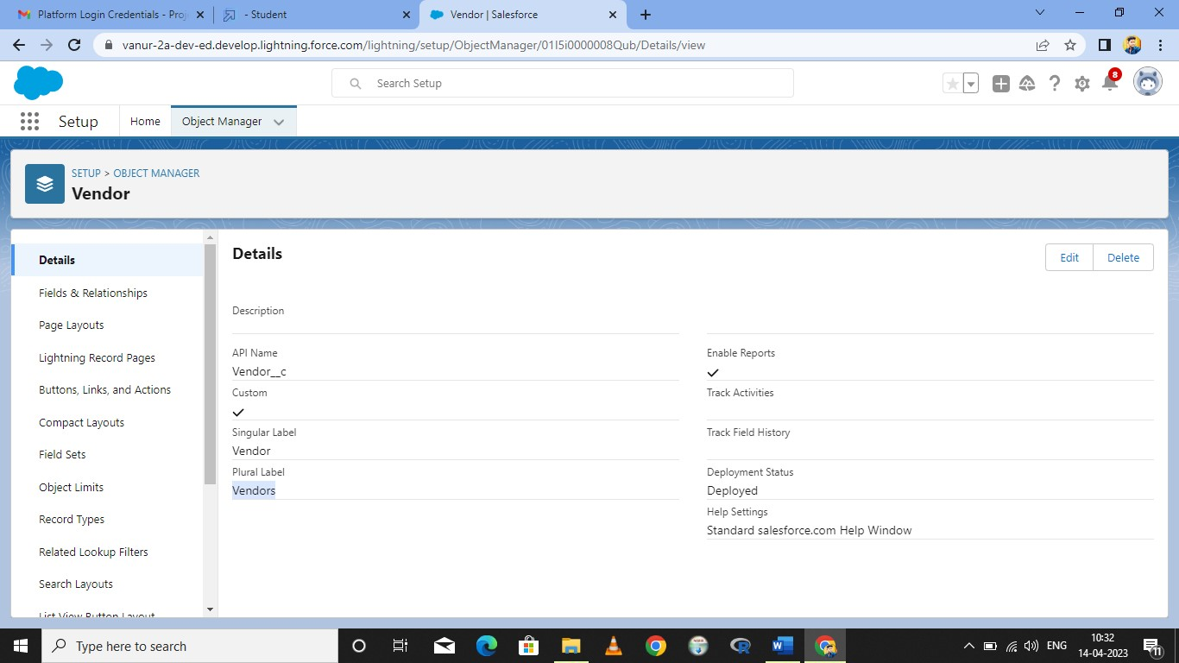

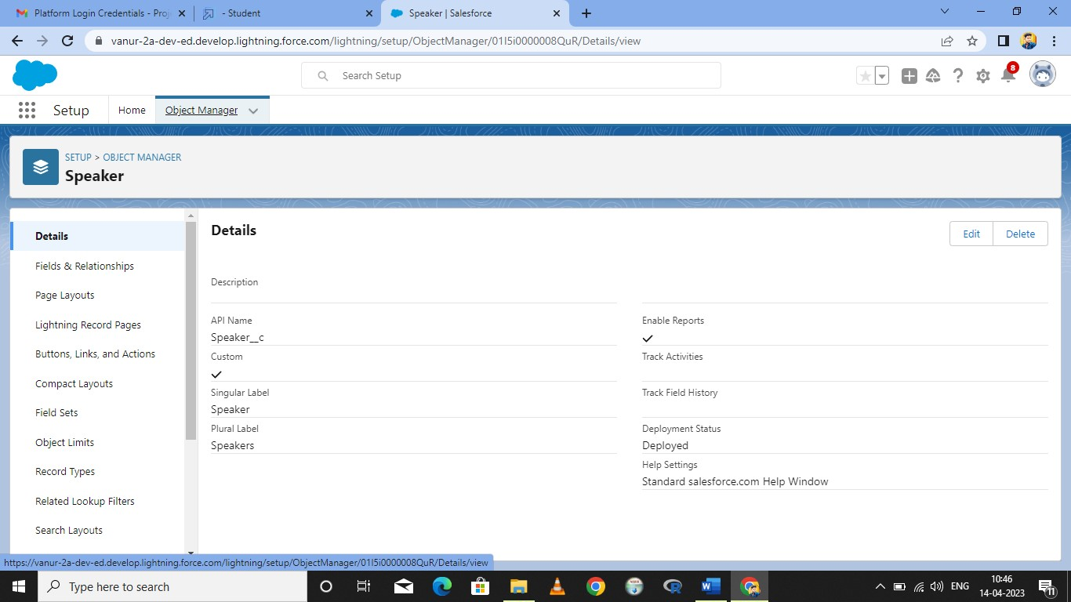

**2. Create a Attendees:**

**Activity 1:**

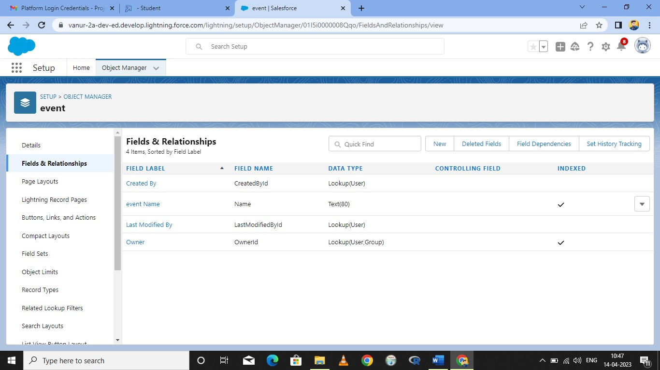

**Activity 2**

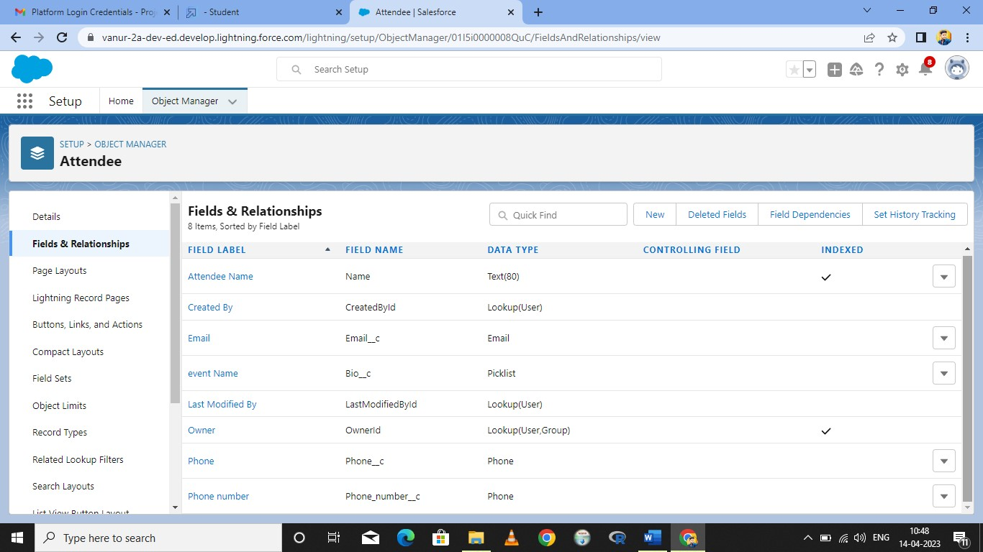

**Activity 3:**

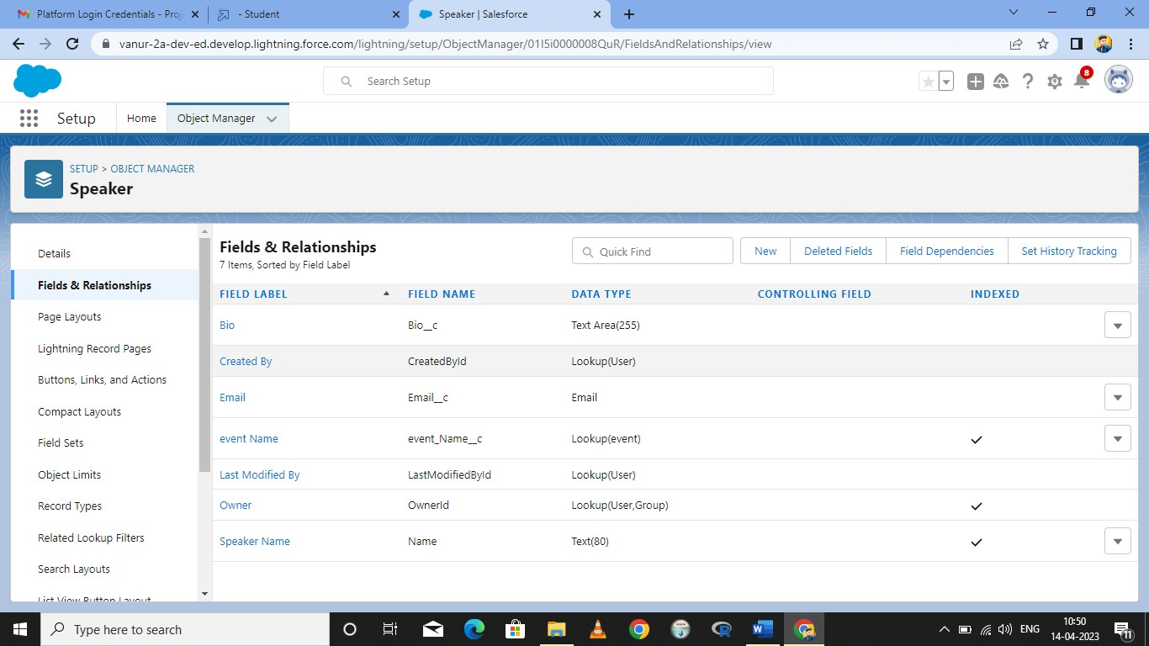

**Activity 4:**

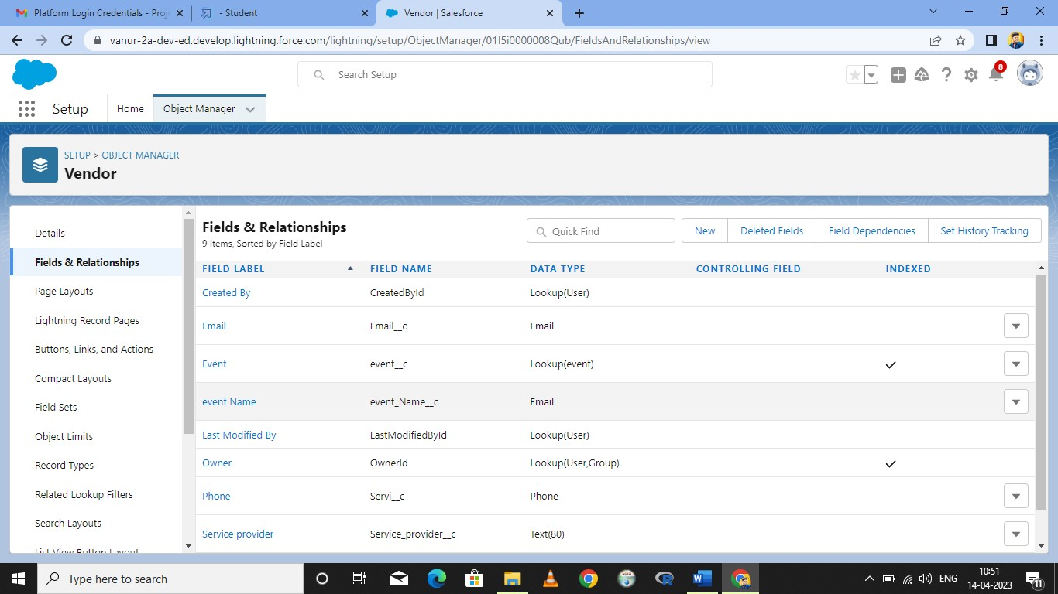

**Create a Tab:**

**Activity 1:**

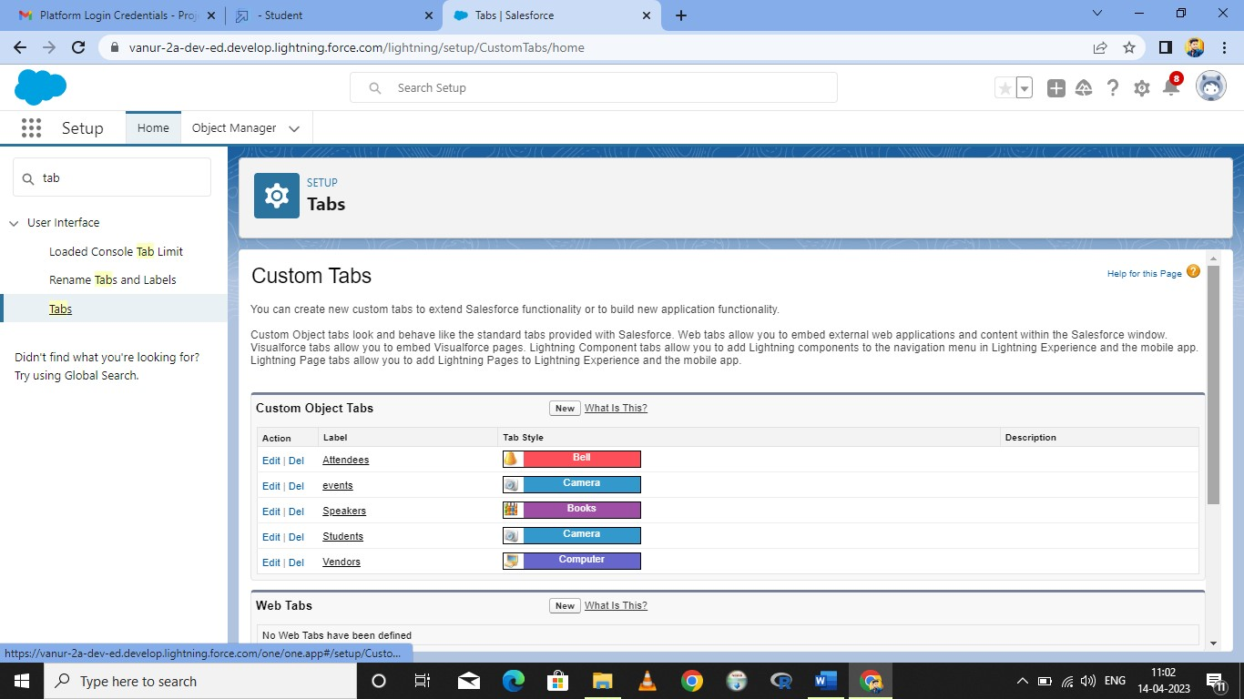

**Creation on profile:**

**Activity 1:**

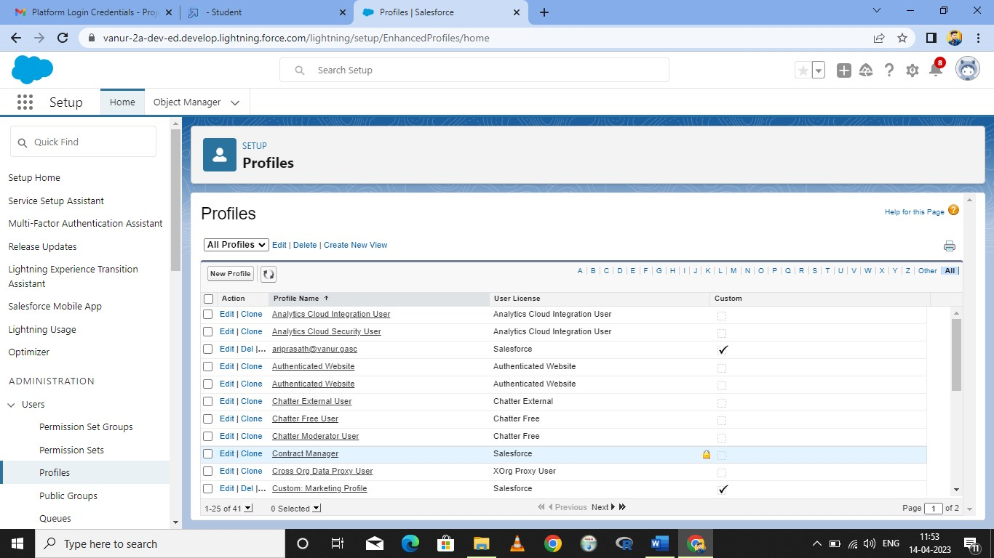

**Activity 2:**

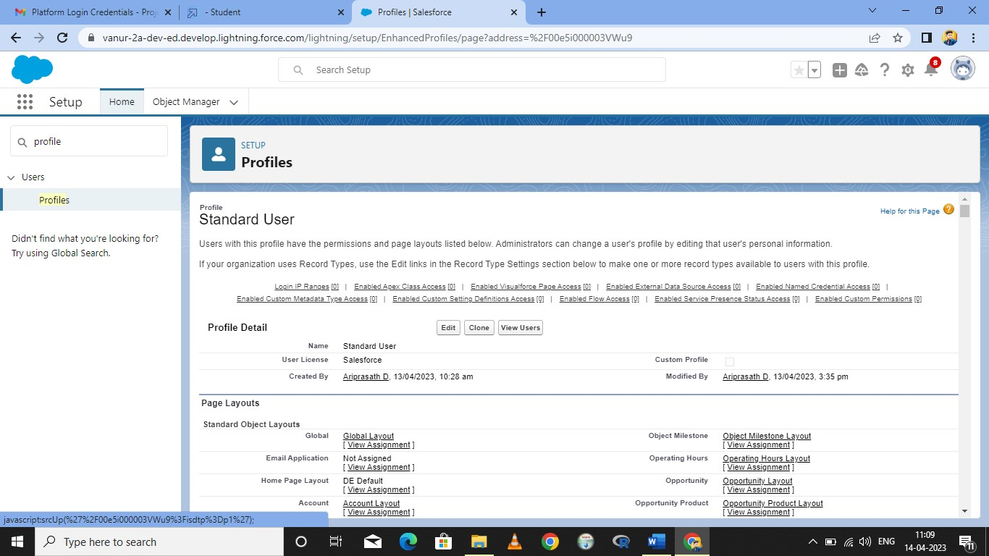

**To Create a User:**

**Activity 1:**

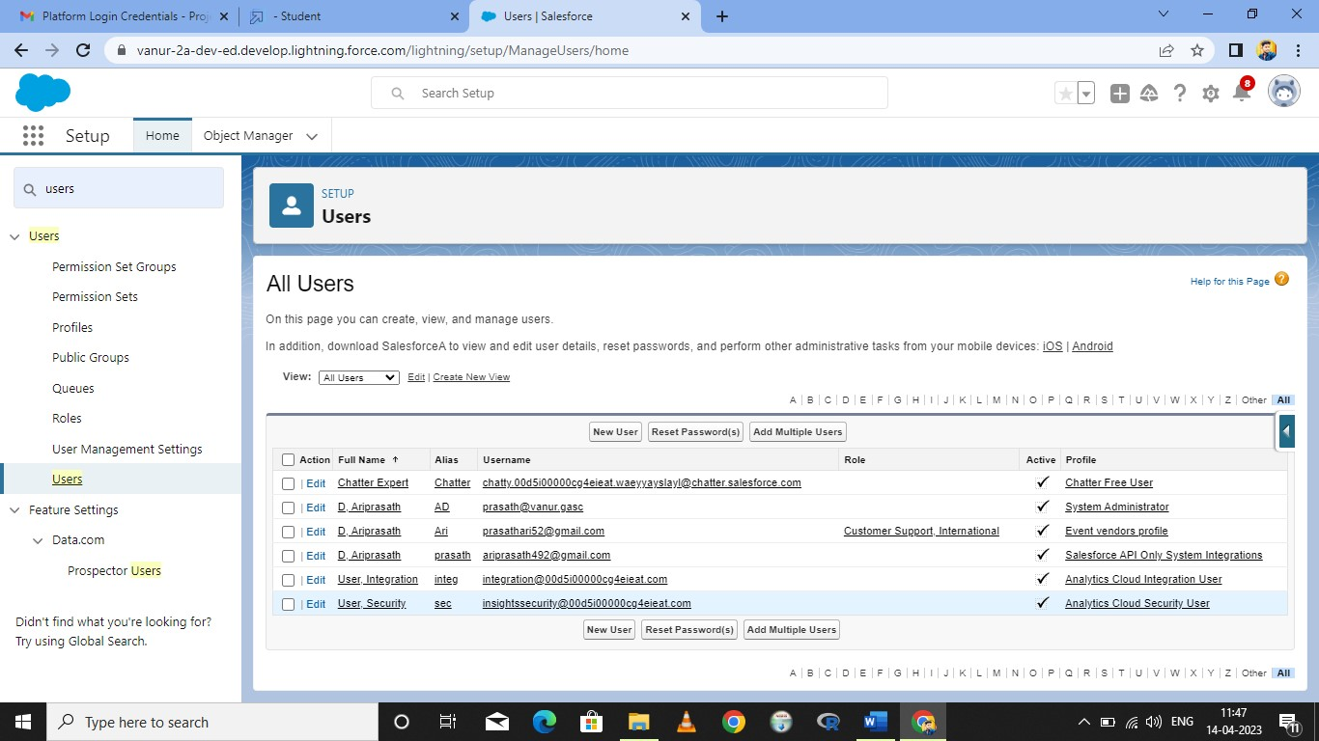

**Create a Permission Set:**

**Activity 1:**

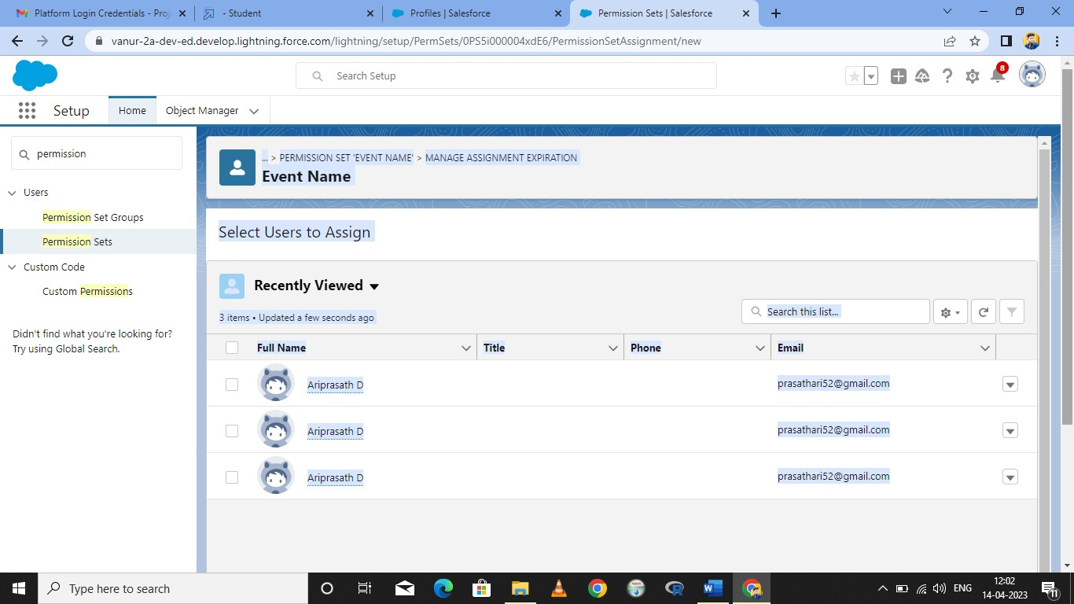

**Create a reort:**

**Activity 1:**

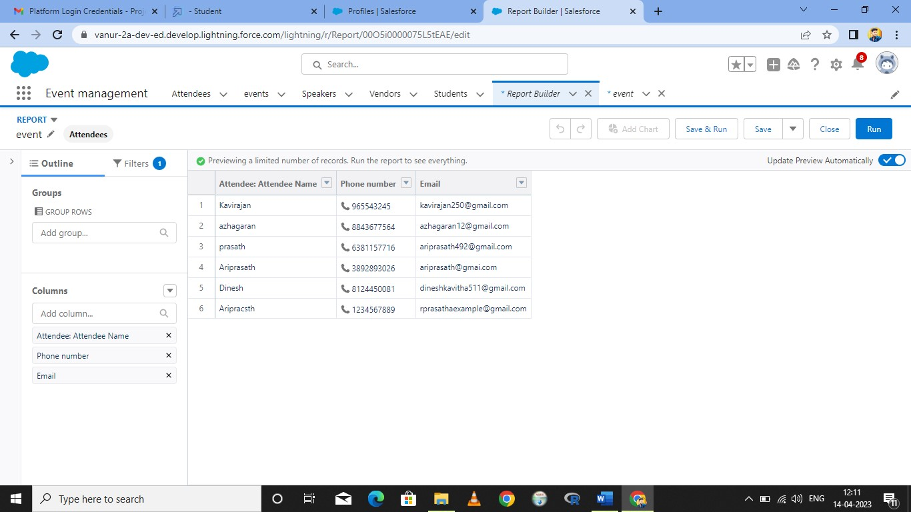

**4. Trailhead profile Public URL:**

**Team Leader(M.Dinesh)- https://trailblazer.me/id/dmunusamy4**

#### **Team Member(D.Ariprasath)-** https://trailblazer.me/id/aprasath17

**Team Member(S.Kavirajan)-** **https://trailblazer.me/id/kavi250 Advantage:** • Easier event management. A dedicated event platform makes the entire event easier to manage. ...

* Saves time. ...
* Cut costs. ...
* Increase engagement. ...
* Analyze and improve. ...
* Automate your event. ...
* Display a greater level of professionalism. ...
* Take a holistic approach to event management.

**Disadvantages:**

* Expensive.
* You have to pay for add-ons to get the most out of the software.
* Configuration and setup is complex and time-consuming.
* Cluttered interface makes navigation and simple tasks unnecessarily complex.
* The learning curve never seems to end.
* Customer support has a poor reputation

**5. Applications**

• Industry insiders believe that a mobile app for an event is a necessity nowadays. 62% of event marketers say that an app can help [drive attendee engagement.](https://blog.bizzabo.com/event-marketing-statistics) We think there are two reasons why event businesses create event planning app. Simplify Event Experience – Using a mobile app, the attendee can conveniently register, purchase a ticket using online payment solutions, check-in with the help of a barcode scanner, etc. This way you can simplify the event experience.

Enhances Attendees’ Interest – Event apps are a good way to enable interaction. Through the app, attendees can participate in live questionnaires, take part in contests and discussions, and more. With this ability of mobile technology to keep participants engaged is how you gain their interest throughout the event.

**6.Conclusion:**

Event Management System is user friendly and cost effective system, it is customized with activities related to event management life-cycle. It provides a new edge to management industry.